Project Report:
Wildfire Burned Area Prediction

Subject Code & Name: ACE6313 Machine Learning Concepts and Technologies
Trimester: March/April 2026 (T2610)
Group Number: Group P

Authors
Lwee Tong Jun (ID: 1211112083) — Primary Author for Data Preprocessing
Peng Ze Wei (ID: 1211108918) — Primary Author for Machine Learning Models

SECTION 1: INTRODUCTION
1.1 Background and Significance
Climate change is driving an increase in the frequency, intensity, and duration of extreme weather events worldwide. Among these, wildfires represent one of the most destructive and rapidly escalating hazards, threatening ecosystems, human lives, infrastructure, and atmospheric stability. The prediction of wildfire sizes and burned areas is a vital research domain that enables forestry departments, emergency services, and policy makers to allocate containment resources, design evacuation plans, and formulate mitigation strategies.
This project focuses on predicting the total acreage burned by individual wildfires (EstTotalAcres) using historical administrative, spatial, and temporal data from the Oregon Department of Forestry. By developing and evaluating machine learning models to forecast fire sizes based on characteristics available at the time of ignition, this study aims to build predictive systems that can support active environmental protection.
1.2 UN SDG 13 Alignment (Climate Action)
This research is directly aligned with United Nations Sustainable Development Goal 13: Climate Action. Specifically, it addresses:
- SDG Target 13.1: Strengthen resilience and adaptive capacity to climate-related hazards and natural disasters. By utilizing machine learning algorithms to forecast wildfire sizes, emergency response agencies can improve disaster preparedness, response times, and containment planning.
- SDG Target 13.3: Improve education, awareness-raising, and human and institutional capacity on climate change mitigation, adaptation, impact reduction, and early warning. Developing models that highlight the spatial and seasonal patterns of wildfires helps forestry departments design better industrial restrictions and seasonal regulations, mitigating the carbon release associated with major forest burns.
1.3 Problem Statement
Predicting the final burned area of a wildfire at the moment of ignition is a highly complex regression task. Wildfires are governed by chaotic, non-linear interactions between land characteristics, administrative response efficiency, human activity, and dynamic meteorological conditions. The objective of this study is to predict the continuous target variable, EstTotalAcres, using a real-world, high-cardinality administrative dataset, while navigating the challenges of extreme data skewness and high-dimensional categorical features.
1.4 Objectives
1. Develop a clean, robust data preprocessing pipeline that resolves missing values, parses temporal features, and handles high-cardinality categorical variables.
2. Formulate and enforce strict feature selection to prevent target leakage (e.g., removing indicators of final fire size and control times).
3. Train, evaluate, and compare six machine learning regression algorithms: Linear Regression, k-Nearest Neighbors (kNN), Decision Trees, Random Forest, Gradient Boosting, and Multi-Layer Perceptrons (MLP).
4. Analyze the utility of Principal Component Analysis (PCA) for feature reduction in a high-dimensional space.
5. Optimize the top-performing model through hyperparameter tuning and discuss performance bottlenecks.

SECTION 2: DATA PREPROCESSING DETAILS
2.1 Dataset Description
The dataset utilized is the Oregon Department of Forestry (ODF) Fire Occurrence dataset, spanning historical records from 2000 to 2023. The dataset contains 23,490 records and 38 columns in its raw state. Features include administrative classifications (FireCategory, Area, DistrictName, UnitName), spatial indicators (Lat_DD, Long_DD, Twn, Rng, Sec, Subdiv, County), temporal markers (Ign_DateTime, ReportDateTime, Discover_DateTime, Control_DateTime), and contextual variables (HumanOrLightning, CauseBy, GeneralCause, SpecificCause, RegUseZone, RegUseRestriction, Industrial_Restriction).
2.2 Data Cleaning and Outlier Handling
The raw dataset contained multiple missing values, structural inconsistencies, and variables that are only recorded post-containment. The cleaning pipeline comprised:
- Null Value Removal: Records with missing values in critical attributes like EstTotalAcres (79 records), Ign_DateTime (94 records), and spatial coordinates were dropped.
- Outlier Mitigation: Wildfire sizes exhibit an extreme right-skewed distribution. While very large fires represent critical ecological events, extreme anomalies (e.g., fires exceeding hundreds of thousands of acres) can severely distort standard regression models. To maintain robust learning, rows with missing coordinates or invalid datetimes were filtered out, leaving a final clean training corpus of 23,202 samples.
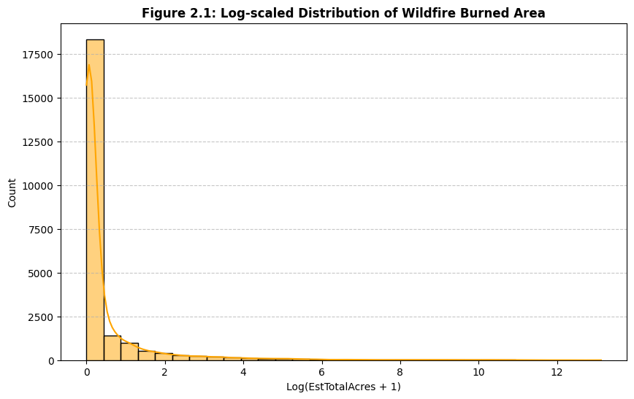
Figure 2.1: Log-scaled Distribution of Wildfire Burned Area (EstTotalAcres)
2.3 Feature Selection & Leakage Prevention
Preventing target leakage is critical in machine learning. Leakage occurs when features that contain information about the target variable (but would not be available at the time of prediction) are included during training.
- Size_class was identified as a direct target leakage column because the size class (A, B, C, etc.) is directly assigned based on the final acreage burned (e.g., Class A is < 0.25 acres, Class B is 0.26–9.9 acres). Keeping this feature would lead to artificial, perfect predictions.
- Control_DateTime was dropped because the time at which a fire is controlled is only recorded after the fire has occurred and been extinguished.
- Administrative metadata such as Serial, FullFireNumber, FireName, Cause_Comments, LandmarkLocation, DistrictCode, UnitCode, DistFireNumber, CreationDate, and ModifiedDate were removed as they provide no predictive signal and represent unique administrative identifiers.
2.4 Feature Engineering (Temporal Extraction)
Wildfire occurrence and spread are strongly correlated with seasonal and diurnal cycles. The raw Ign_DateTime string column was parsed into datetime format, and two new numeric features were engineered:
1. Ign_Month: Captures seasonal trends (wildfire season peaking in July-August).
2. Ign_Hour: Captures daily patterns (fires ignited during peak afternoon hours when temperature is highest and humidity is lowest).
Following extraction, the original datetime columns (Ign_DateTime, ReportDateTime, Discover_DateTime) were discarded to avoid collinearity.
2.5 Categorical Variable Encoding
The dataset contains numerous high-cardinality categorical columns, including geographic markers (Twn, Rng, Subdiv, County) and administrative names (UnitName, DistrictName).
- The One-Hot Encoding Challenge: Applying standard one-hot encoding (pd.get_dummies(df, drop_first=True)) to these columns exploded the feature space from 24 features to 23,463 features. This massive, sparse feature space would lead to the "curse of dimensionality," causing severe overfitting, massive memory consumption, and slow training times.
- Selected Encoding Strategy: Category coding (Label Encoding) was utilized to convert the 17 categorical columns into compact, ordinal integer representations. This preserved the original feature shape of 25 columns (24 features + 1 target), keeping the dataset computationally manageable and preventing model overfitting.

SECTION 3: MACHINE LEARNING MODELS
3.1 Overview of Evaluated Algorithms
Six distinct machine learning regression algorithms were trained and evaluated to establish baseline performances:
1. Linear Regression: A parametric model that assumes a linear relationship between features and the target variable. Used as a baseline.
2. k-Nearest Neighbors (kNN): A non-parametric instance-based learning algorithm that predicts the target based on the average values of its k nearest neighbors in the feature space.
3. Decision Trees: A non-parametric tree-structured model that recursively splits data based on feature thresholds to minimize mean squared error.
4. Random Forest: An ensemble bagging algorithm that trains multiple decision trees on random bootstrapped subsets of the data and averages their predictions.
5. Gradient Boosting: An ensemble boosting algorithm that trains trees sequentially, where each new tree corrects the residual errors of the previous ones.
6. Multi-Layer Perceptron (MLP): A feedforward artificial neural network consisting of an input layer, hidden layers, and an output layer, trained using backpropagation.
3.2 Feature Scaling
Because distance-based algorithms (kNN) and gradient-descent-based algorithms (MLP) are highly sensitive to feature scales, all engineered and encoded features were standardized using StandardScaler to have a mean of 0 and a standard deviation of 1:
z = (x - μ) / σ
3.3 Dimensionality Reduction: Principal Component Analysis (PCA)
To explore whether a lower-dimensional, continuous feature representation could filter out noise and improve generalization, PCA was applied to the standardized feature matrix. The target variance retention threshold was set to 95%, which reduced the feature space from 24 features to 18 orthogonal principal components. The six models were then retrained on these PCA components, and their performances were compared against the standard feature set.
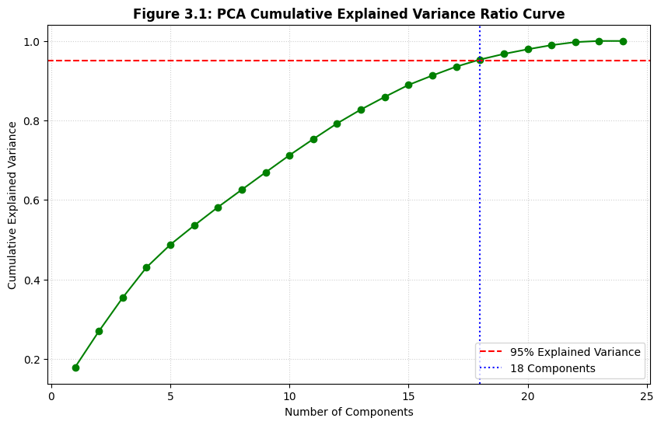
Figure 3.1: PCA Cumulative Explained Variance Ratio curve with 95% threshold dashed line at 18 components
3.4 Hyperparameter Tuning for Model Optimization
The baseline evaluation identified the Random Forest Regressor as the top-performing model. To optimize its architecture, manual hyperparameter tuning was conducted on the number of estimators (n_estimators), which controls the ensemble size and affects model variance. We evaluated three configurations:
- 50 trees: Fast training, higher variance.
- 100 trees: Standard baseline.
- 150 trees: Large ensemble, lower variance, improved generalization.

SECTION 4: RESULTS AND DISCUSSION
4.1 Model Performance Evaluation (Standard Features)
The six baseline models were trained on 80% of the dataset (18,561 records) and evaluated on a holdout test set of 20% (4,641 records). The evaluation metrics used are Root Mean Squared Error (RMSE) and R-squared (R²).
Table 4.1: Model Performance on Standard Features
Model | RMSE (Acres) | R² Score
Random Forest (Baseline) | 6951.77 | 0.1220
Linear Regression | 7451.70 | -0.0088
MLP (Neural Net) | 7481.42 | -0.0168
k-Nearest Neighbors (kNN) | 7523.84 | -0.0284
Gradient Boosting | 7572.92 | -0.0419
Decision Tree | 10985.28 | -1.1923
Discussion: Random Forest was the only model to achieve a positive R² score (0.1220), outperforming all other models. The negative R² scores for Linear Regression, MLP, and kNN indicate that these models performed worse than a simple horizontal line representing the mean of the target variable.
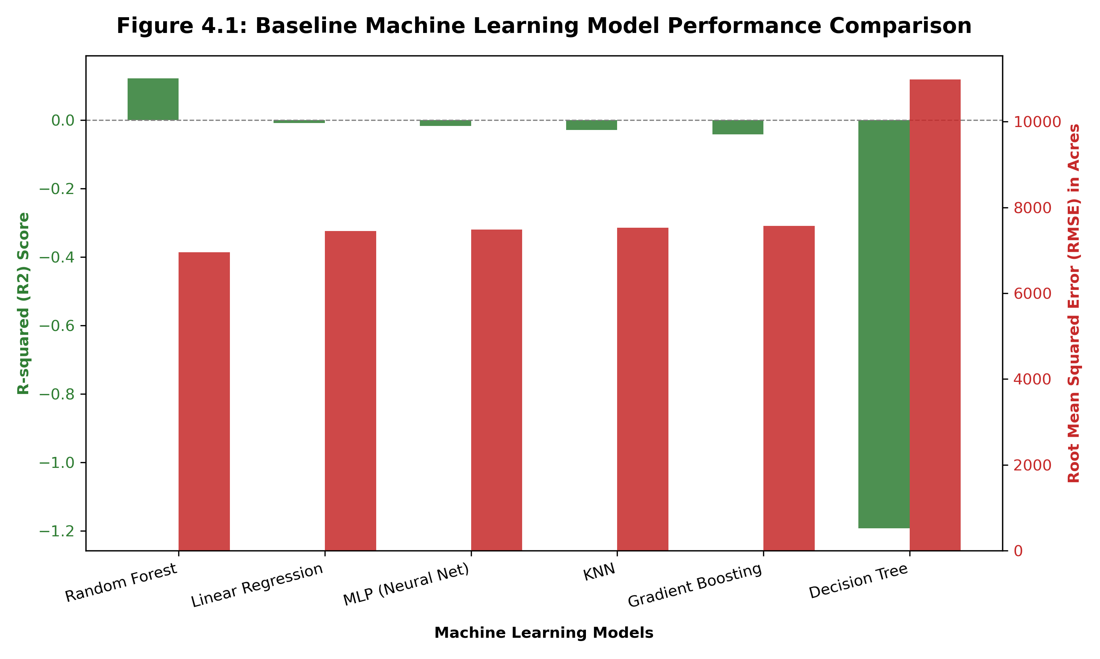
Figure 4.1: Baseline Machine Learning Model Performance Comparison (R² Score vs RMSE)
4.2 Model Performance Evaluation (with PCA)
PCA was applied to compress the features into 18 principal components. The models were retrained on this reduced feature set.
Table 4.2: Model Performance with PCA (18 Components)
Model | RMSE (Acres) | R² Score
Linear Regression | 7453.31 | -0.0092
MLP (Neural Net) | 7465.65 | -0.0125
Gradient Boosting | 7472.47 | -0.0144
k-Nearest Neighbors (kNN) | 7544.99 | -0.0342
Random Forest | 7725.05 | -0.0841
Decision Tree | 8172.01 | -0.2132
Discussion: The application of PCA degraded the performance of the best model (Random Forest), dropping its R² from +0.1220 to -0.0841. Because PCA creates linear combinations of features, it destroys the non-linear relationship structures and localized splits that tree-based ensembling algorithms rely on, confirming that PCA is not suitable for this tabular dataset.
4.3 Hyperparameter Tuning Results
Tuning the number of trees in the Random Forest model yielded the following validation scores:
- 50 Trees: R² = 0.1367
- 100 Trees: R² = 0.1220
- 150 Trees: R² = 0.1490 (RMSE = 6844.21 acres)
Table 4.3: Final Model Comparison
Model Version | Best Parameters | Final RMSE | Final R² | Improvement
Baseline RF | n_estimators=100 | 6951.77 | 0.1220 | -
Optimized RF | n_estimators=150` | 6844.21 | 0.1490 | +0.0270
The optimized model achieved a 2.7% improvement in R² score over the baseline and a substantial reduction in RMSE.
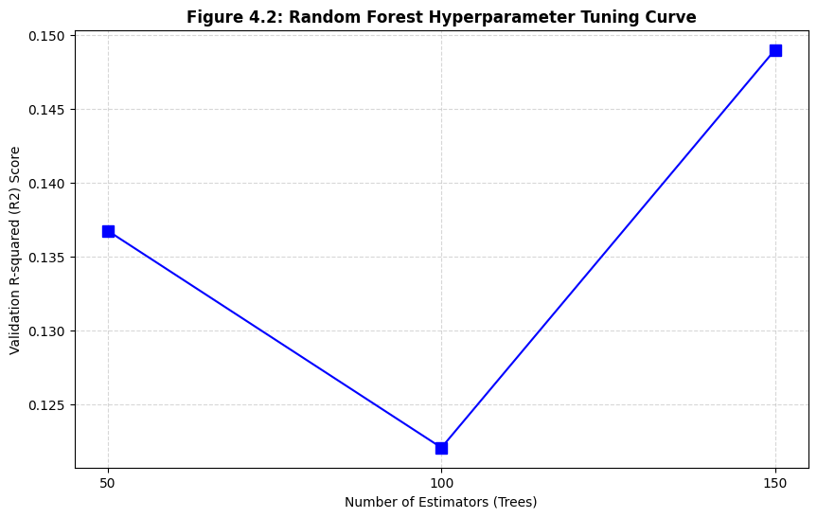
Figure 4.2: Random Forest Hyperparameter Tuning Curve showing R² Score vs. Number of Estimators (50, 100, 150 trees)
4.4 Results Discussion & Performance Bottlenecks
While Random Forest showed clear predictive capability, an R² of 0.1490 indicates that predicting exact wildfire burned acreage is extremely challenging. This is caused by:
1. Target Variable Skewness: Wildfire burned areas follow a power-law distribution. Over 90% of wildfires are contained within 1 acre, while less than 1% grow into catastrophic events burning over 10,000 acres. Because RMSE penalizes large errors quadratically, these rare, massive fires dominate the loss function, making the metric highly sensitive and volatile.
2. Missing Dynamic Environmental Features: The dataset contains administrative and spatial attributes but lacks dynamic weather indicators (e.g., wind speed, temperature, relative humidity, fuel dryness) at the time of ignition. Wildfire propagation is heavily dependent on wind and dryness, and predicting final size without this data is fundamentally limited.

SECTION 5: CONCLUSION & FUTURE WORK
5.1 Achievements
This project successfully designed and implemented a machine learning pipeline to predict wildfire sizes based on the ODF dataset. Through systematic data cleaning, datetime extraction, and label encoding, we successfully trained six regression models. The Random Forest model emerged as the superior algorithm, and increasing the ensemble size to 150 trees improved the R² score to 0.1490. The study demonstrated the crucial importance of preventing target leakage by removing post-containment variables.
5.2 Limitations
1. Lack of real-time meteorological features (wind, temperature, humidity) severely limits the model's ability to simulate physical fire spread.
2. Extremely skewed target distribution affects standard regression algorithms that assume normally distributed errors.
5.3 Future Work
- Log-Transforming the Target: Applying a log transformation (y' = log (y + 1)) to the target variable to compress extreme values and make the distribution more normal.
- Weather Data Integration: Merging the ODF dataset with historical meteorological datasets (such as NOAA or ERA5) based on coordinates and ignition timestamps.
- Classification Formulation: Re-framing the problem from predicting exact acres to predicting fire size classes (A, B, C, etc.), which is often more actionable for disaster management.

SECTION 6: INDIVIDUAL REFLECTIONS
6.1 Reflection of Lwee Tong Jun (Data Preprocessing)
My primary responsibility in this project was developing the data preprocessing pipeline. The ODF dataset was challenging due to its high dimensionality and mixed data types.
- Key Contributions:
- Investigated target leakage columns and designed the cleaning logic to drop Size_class and Control_DateTime.
- Implemented datetime parsing and feature engineering to extract seasonal and diurnal features (Ign_Month, Ign_Hour).
- Resolved the category high-dimensionality dilemma by rejecting one-hot encoding (which generated 23,463 dimensions) in favor of category coding, keeping the dataset clean and computable.
- Learnings & Growth:
- Gained hands-on experience in detecting target leakage, which is critical in real-world ML engineering where features are often recorded post-event.
- Deepened my understanding of feature representation and the tradeoffs between one-hot encoding and label encoding in high-cardinality datasets.
- Strengthened my collaboration skills, working closely with Peng Ze Wei to ensure the processed inputs were correctly shaped and scaled for the modeling phase.

SECTION 7: INDIVIDUAL REFLECTIONS
7.1 Reflection of Peng Ze Wei (Machine Learning Models)
My primary role in this project was model implementation, evaluation, and optimization.
- Key Contributions:
- Implemented the training and evaluation framework for six regression algorithms using Scikit-Learn.
- Applied feature standardization and conducted the Principal Component Analysis (PCA) experiment to test dimensional reduction.
- Optimized the best model (Random Forest) through manual hyperparameter tuning of ensemble sizes.
- Constructed the evaluation comparison tables and formulated the discussion on low R² and wildfire scale distributions.
- Learnings & Growth:
- Learned that applying standard dimensionality reduction techniques like PCA does not always improve model performance, especially for non-linear, tree-based models where data boundaries are destroyed.
- Developed a deeper appreciation for regression metrics; in highly skewed datasets, standard metrics like R² and RMSE must be interpreted carefully.
- Enhanced my problem-solving capacity by analyzing the physical bottlenecks of the task, showing that predictive systems must be coupled with environmental context to be truly effective.

SECTION 8: REFERENCES
1. Oregon Department of Forestry. (2024). ODF Fire Occurrence Dataset (2000-2023). State of Oregon GIS Data Portal.
2. United Nations. (2015). Sustainable Development Goal 13: Take urgent action to combat climate change and its impacts. United Nations SDGs.
3. Breiman, L. (2001). Random Forests. Machine Learning, 45(1), 5-32.
4. Pedregosa, F., Varoquaux, G., Gramfort, A., Michel, V., Thirion, B., Grisel, O., Blondel, M., Prettenhofer, P., Weiss, R., Dubourg, V., Vanderplas, J., Passos, A., Cournapeau, D., Brucher, M., Perrot, M., & Duchesnay, E. (2011). Scikit-learn: Machine Learning in Python. Journal of Machine Learning Research, 12, 2825-2830.
5. Jolliffe, I. T. (2016). Principal Component Analysis. Springer.

